PYTHON PROJECT
NAME : Nikilesh Prakash V
REG NO : 411625149029
DEPARTMENT : B.E Cyber Security
SUBJECT : PYTHON
BATCH : 4
PROJECT TITLE : LIBRARY MANAGEMENT SYSTEM USING PYTHON

PROBLEM STATEMENT
To design and implement a Library Management System using Python that helps manage books using a menu-driven approach. The system allows users to add, view, issue, and return books using loops and conditional statements.

OBJECTIVE
- To understand loops and conditional statements
- To implement menu-driven programming
- To manage library records using Python
- To simulate real-world library system

TOOLS USED
- Python 3
- VS Code / IDLE

DESCRIPTION
This project simulates a simple Library Management System. The user can add books, view books, issue books, and return books using a menu-driven approach. It uses loops for repetition, lists for storing data, and conditions for decision making.

ALGORITHM
- Create empty lists for book names and status
- Display menu using while loop
- Read user choice
- If add book → store book in list
- If view book → display books using loop
- If issue book → update status
- If return book → change status
- Repeat until exit

CODING
# Library Management System using Loops

book_name = []
book_status = [] # "Available" or "Issued"

while True:
print("\n====== LIBRARY MENU ======")
print("1. Add Book")
print("2. View Books")
print("3. Issue Book")
print("4. Return Book")
print("5. Exit")

choice = int(input("Enter your choice: "))

# ADD BOOK
if choice == 1:
n = int(input("How many books to add? "))

for i in range(n):
name = input("Enter book name: ")
book_name.append(name)
book_status.append("Available")

print("Books added successfully ✅")

# VIEW BOOKS
elif choice == 2:

if len(book_name) == 0:
print("No books in library ❌")

else:
print("\nBook List:")

for i in range(len(book_name)):
print(i+1, ".", book_name[i], "-", book_status[i])

# ISSUE BOOK
elif choice == 3:

issue = input("Enter book name to issue: ")

found = False

for i in range(len(book_name)):

if book_name[i] == issue:

found = True

if book_status[i] == "Available":
book_status[i] = "Issued"
print("Book issued successfully ")
else:
print("Book already issued ")

break

if found == False:
print("Book not found ")

# RETURN BOOK
elif choice == 4:

ret = input("Enter book name to return: ")

found = False

for i in range(len(book_name)):

if book_name[i] == ret:

found = True

if book_status[i] == "Issued":
book_status[i] = "Available"
print("Book returned successfully ")
else:
print("Book was not issued ")

break

if found == False:
print("Book not found ")

# EXIT
elif choice == 5:
print("Thank you for using Library System ")
break

else:
print("Invalid choice Try again")
OUTPUT
The program displays menu options and performs library operations based on user input.
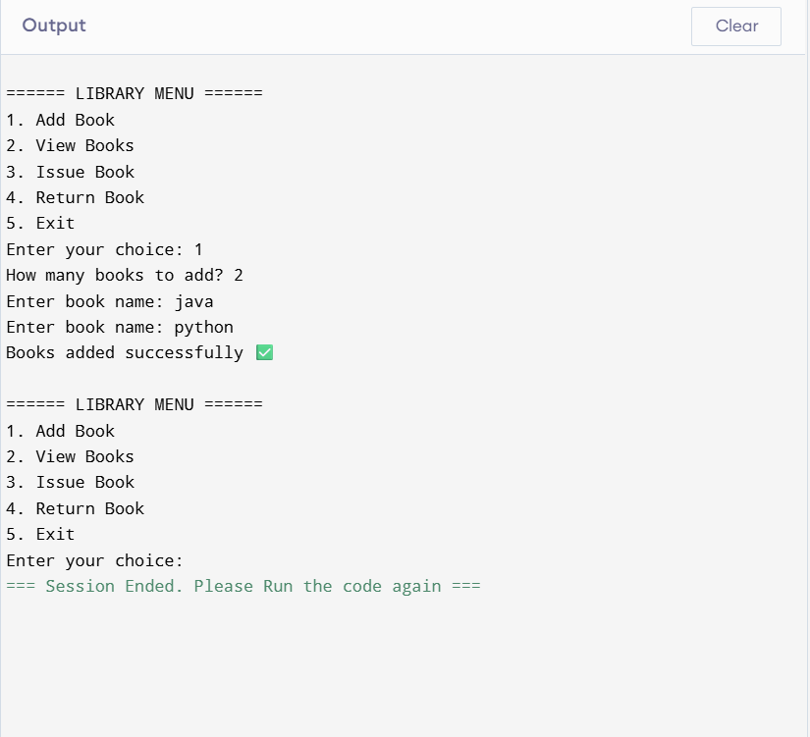

RESULT
The Library Management System successfully manages books using loops and conditions. Users can add, issue, and return books efficiently.

CONCLUSION
This project demonstrates the use of Python loops and menu-driven programming to build a simple and effective Library Management System.

